The Beginning

Hi! I’m Stephanie, a first-year intern here in the Stanford Earth Young Investigators (SEYI).

This is my very first time contributing to a formal research program where I help answer the question: how animals’ body size has evolved over 3.8 billion year history of life on Earth? Although it has only been a couple of weeks since the program had started, I’ve learned countless things, from how to critically read a scientific paper to coding in R.

On the first official day of the internship, Dr. Noel Heim introduced to us the Geologic Time Scale and we had the opportunity re-create it ourselves using the information we had gathered as a group. This gave me a sense of the scale of events that happened in the past 4.5 billion years ago ranging from the minuscule to the substantial events. During the process, I not only learned about Earth’s history, I also got to bond with other interns in the biodiversity group.

Two major skills I have acquired in the past couple of weeks are reading scientific papers and coding in R, a programming language for statistical computing and graphics. Although we have only read a total of four scientific papers, I noticed my improvement throughout the process. Previously I took more than an hour to analyze the reading, but now it takes me to only thirty minutes! Before this program, I had no experience with coding not to mention coding with the software, R. During the couple days of learning the concepts of R and the help of Noel and other interns, I was able to be familiarized with R.

Today we went to New Brighton State Beach and the Seymour Marine Discovery Center to observe the fossils of marine animals! This was especially exciting for me (and I believe the other biodiversity interns also) because we have been conducting research and labs on these specific species. This was our chance to discover and examine the fossils ourselves and apply our newly acquired knowledge on the field.

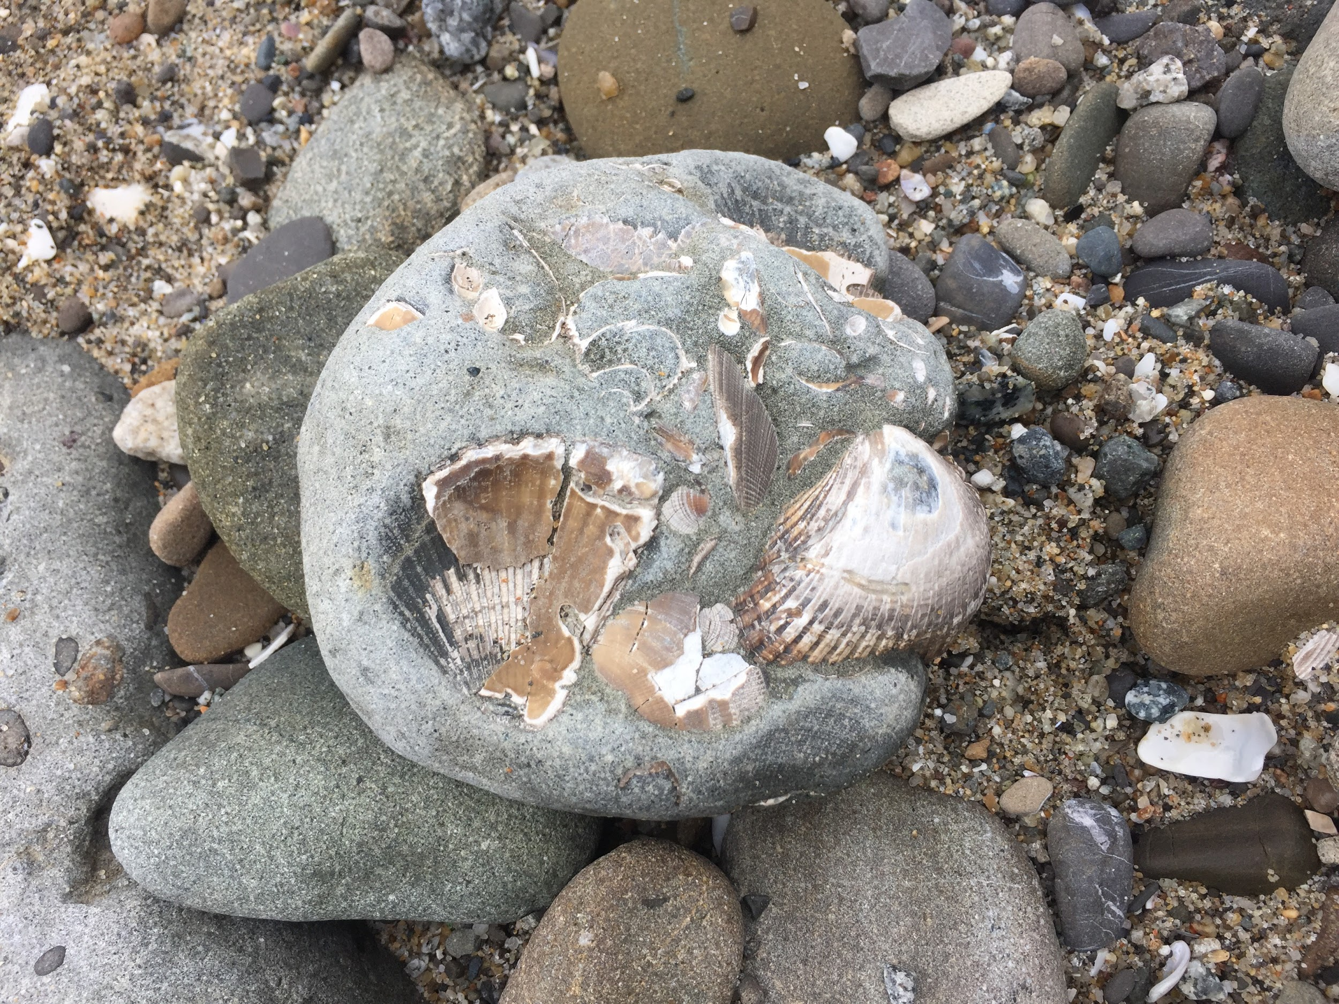

Overall, I am very grateful to be a part of the Stanford Earth Young Investigators (SEYI) this summer! I cannot wait to begin writing a paper on my research topic!